1a)

Herbrand universe: apollo, zeus, heracles, Socrates

Herbrand base: farther(term,zeus), divine(term), mortal(term), human(term), abnormal(term) term∊HU

* Not sure if it should be farther(term,zeus) or farther(term,term)

1b)

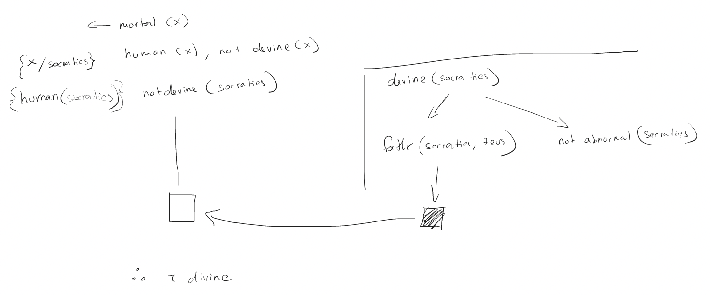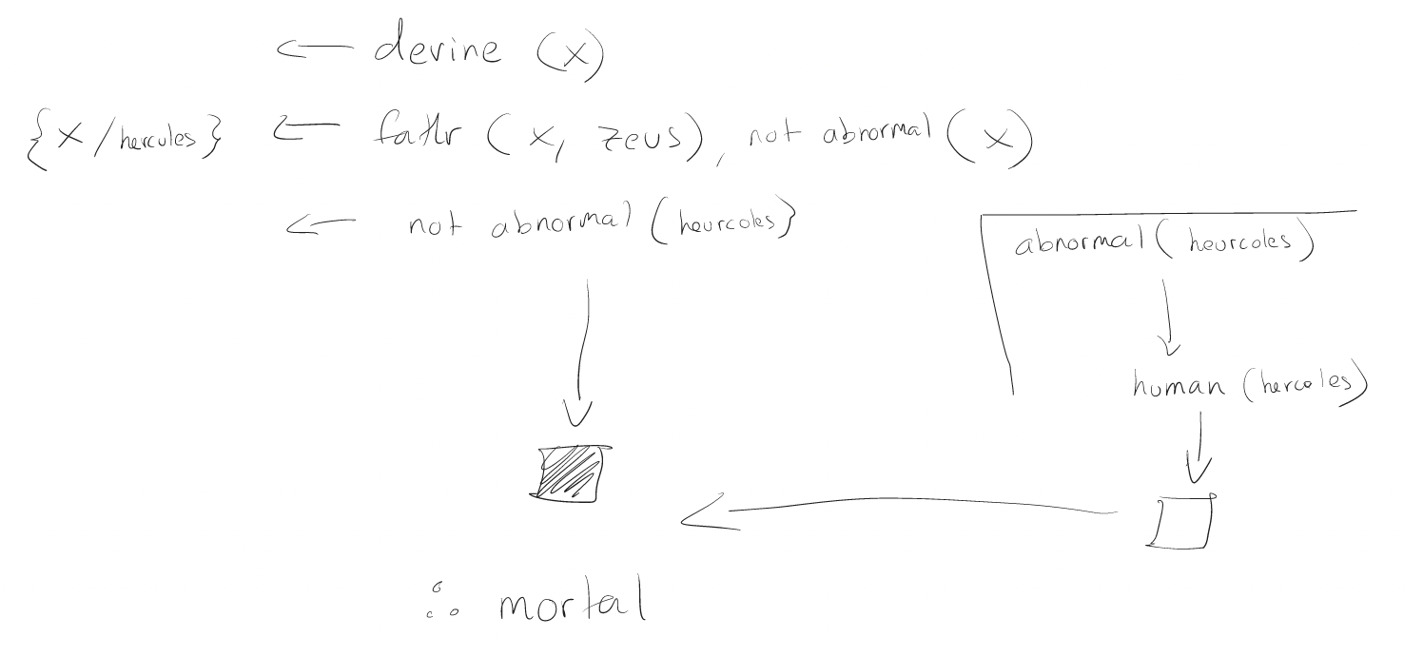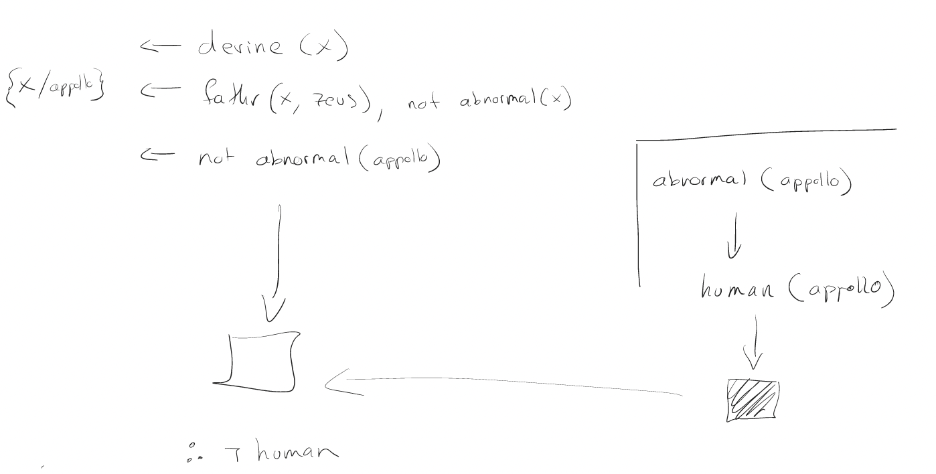

1c)

All grounded rules

mortal(socrates) <- human(socrates), not divine(socrates)

mortal(heracles) <- human(heracles), not divine(heracles)

mortal(zeus) <- human(zeus), not divine(zeus)

mortal(apollo) <- human(apollo), not divine(apollo)

divine(socrates) <- farther(socrates, zeus), not abnormal(socrates)

divine(heracles) <- farther(heracles, zeus), not abnormal(heracles)

divine(zeus) <- farther(zeus, zeus), not abnormal(zeus)

divine(apollo) <- farther(apollo, zeus), not abnormal(apollo)

abnormal(socrates) <- human(socrates)

abnormal(heracles) <- human(heracles)

abnormal(zeus) <- human(zeus)

abnormal(apollo) <- human(apollo)

human(socrates) <-

human(heracles) <-

farther(heracles,zeus) <-

farther(apollo,zeus) <-

**Model = human(socrates), human(hercules), farther(heracles,zeus), farther(apollo,zeus), mortal(socrates), mortal(hercules), divine(apollo), abnormal(socrates), abnormal(hercules)**

Delete rules with negations of these literals then delete remaining negative literals

mortal(socrates) <- human(socrates)

mortal(heracles) <- human(heracles)

mortal(zeus) <- human(zeus),

divine(zeus) <- farther(zeus, zeus)

divine(apollo) <- farther(apollo, zeus)

abnormal(socrates) <- human(socrates)

abnormal(heracles) <- human(heracles)

abnormal(zeus) <- human(zeus)

abnormal(apollo) <- human(apollo)

human(socrates) <-

human(heracles) <-

farther(heracles,zeus) <-

farther(apollo,zeus) <-

LHM of this is same as Model therefore stable, this is only stable model

1d) since we only have one stable model this is the same as our well founded model, any literals in our well founded model we can infer are true and so since mortal(socrates), mortal(hercules), divine(apollo) are in the model we can infer these are the true states for these individuals